File permissions in Linux

Project description
Permissions for the research team have not been updated to match the required authorization. I have analyzed and corrected these permissions within the projects directory to improve the security posture of the organization.

Check file and directory details
As seen in the screenshot below, I used linux commands to view and analyze the existing permission set for projects directory.

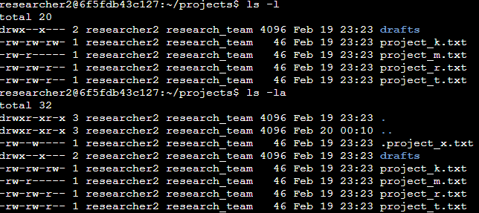

The first command I used was the ls command to check the permissions of the directory and the files within it. Then I used the ls command with the -la option to include the hidden files in the analysis. This directory includes one hidden file named .project_x.txt, five other files and one directory named drafts.

Describe the permissions string
The 10-character string in the first column of the file contents is the permissions string. This string details the file or directory permissions for each owner type. Below I have detailed each section of the string.
- First character: If it is a d, its a directory and if its a hyphen (-), its a regular file.
- 2nd-4th characters: These characters represent the read (r), write (w) and execute (x) permissions for the user. If it's a hyphen (-) then it does not have that permission.
- 5th-7th characters: These characters represent the read (r), write (w) and execute (x) permissions for the group. If it's a hyphen (-) then it does not have that permission.
- 8th-10th characters: These characters represent the read (r), write (w) and execute (x) permissions for all the other users. If it's a hyphen (-) then it does not have that permission.

Change file permissions
The organization does not want other to have write access on any files so I found that the file project_k.txt had incorrect permissions. The following code shows what I did using Linux commands:

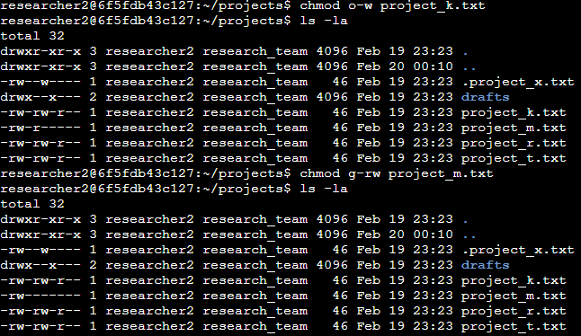

I used the chmod command to correct these permissions and remove the write permission from the other for the project_k.txt file. I also corrected the project_m.txt file since it is a restricted file and should not be readable or writable by the group or other.

Change file permissions on a hidden file
I have been informed that the .project_x.txt file is an archived file that should not be written to by anyone but the user and group should still be able to read it.

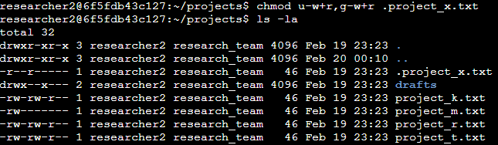

As you can see, the .project_x.txt file is hidden since the name starts with a period (.). Using chmod, I adjusted the permissions to make sure that the only permissions this file has is for the user and group to be able to read it.

Change directory permissions
The final change my organization wanted to fix is the permissions of the drafts directory. Only the user should be able to access and execute the directory. I did the following in linux to achieve this:

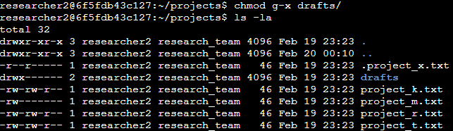

I removed the execute permission from the group so that now only the user has full permissions and the group and others have none.

Summary
Linux commands such as ls -la helped me analyze and chmod helped me change the permissions of hidden and viewable files as well as directories. My organization instructed me on the permission changes and I was able to put these changes into place to better the security posture of the organization.

